Wall Street Fighters – User Manual

1. Introduction
Wall Street Fighters is a technical analysis application, designed for use by novice and intermediate stock traders. It allows to view stock charts, compare them and analyze using various technical analysis tools. This manual doesn't include description and principles of technical analysis – these informations can be found on our website. The authors of the Wall Street Fighters would also note that they do not take any responsibility for potential financial losses caused by using this software.

2. Installation and requirements
Wall Street Fighters is a cross-platform application and should work on Windows XP and higher, Mac OS ? and Linux. Since the application downloads up-to-date stock data from the Internet, it requires a working network connection.
To install the application on Windows, just run the installer file and follow the instructions on the screen.

3. Interface overview
The application user interface is based on „tabs”. There are three main tabs, which are permanent, i. e. they cannot be closed. These tabs are called Home, Search and Settings and they will be described in the following sections. It is also possible to open additional tabs, where the charts are displayed. These tabs can be closed by clicking the „X” at the right end of the tab.
It is worth noting that upon closing, the application remembers the configuration of opened tabs and restores them on startup. It means that you don't have to open charts of financial instruments that you are interested in each time you start the application.

4. Home Tab
The Home Tab is the default tab that is opened after the first startup of the application. It contains all the most vital stock data. On the left hand side there are tables which contain information about most active, most gaining and most losing companies. On the upper right side you can preview current values of the most important indexes, resources and currencies. Below them, there is the RSS feeds browser, which provides you with all the up-to-date relevant market news. You can customize the sources of RSS feeds by adding, removing and editing them using the appropriate buttons.
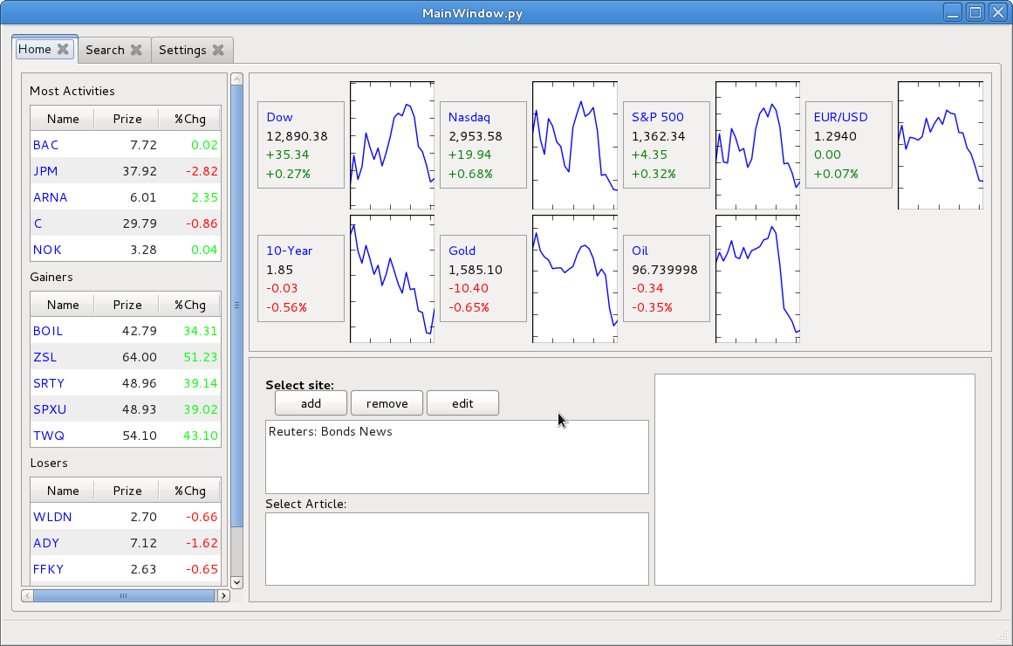
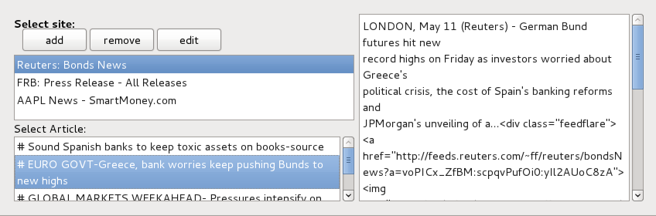
The Home Tab overview
Home Tab – RSS feeds expanded

5. Search Tab
The Search Tab allows you to browse, search and choose financial instruments that you want to analyze. The financial instruments are divided into categories: indexes, stock, bonds, currencies (forex), resources and futures contracts. The „stock” category is also subdivided into indexes where the companies belong such as: WIG20, NASDAQ, NYSE etc.
To search an instrument by name (or ticker), type its name (or a fragment of name) into the text field at the left top corner of the tab. The searching is dynamic, which means that you don't have to press any button - data is being processed simultaneously as you type.
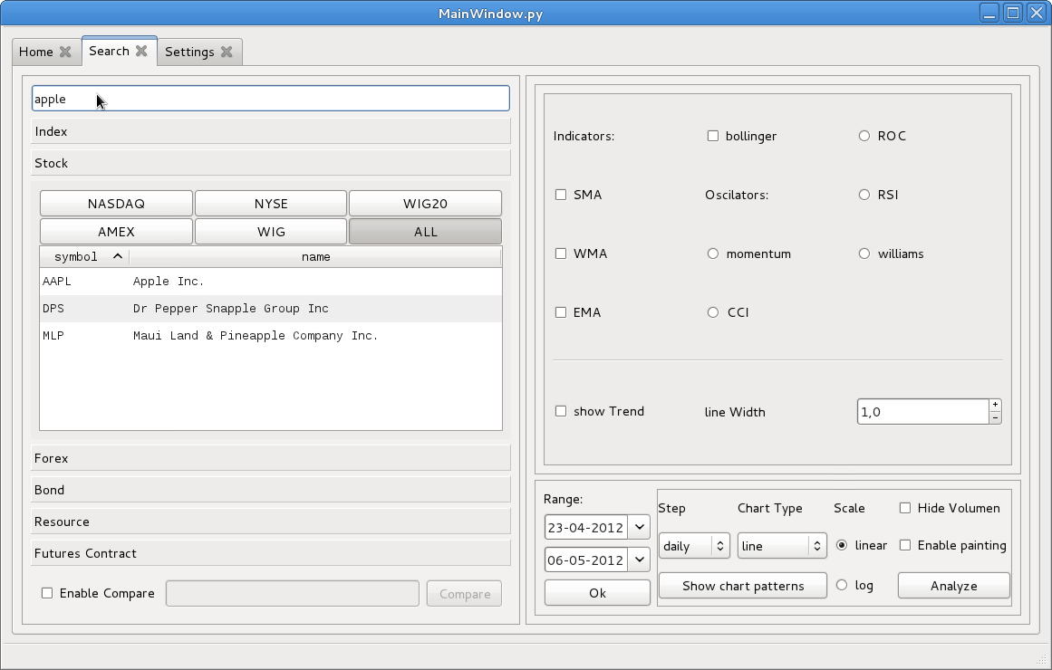
The Search Tab with search example
To view a chart of the selected instrument, double click its name on the list. A new tab with the chart will be opened. You can open multiple tabs with different charts. There is also a possibility to compare multiple financial instruments on one chart. To do this, you need to select the „Enable Compare” checkbox. Then as you click symbols on the lists, they will be added to the text field right next to the checkbox mentioned before. You can also type symbols manually into the checkbox, separating them with „vs”. Once you are done with choosing instruments of your choice, click the Compare button to see them all on one chart.
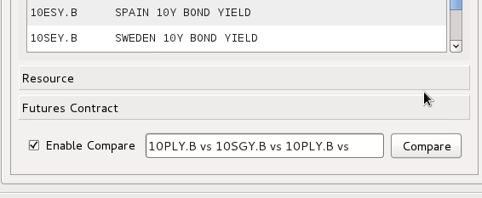
Comparing 10-year bonds of multiple countries

6. Settings Tab
The Settings Tab allows the user to customize the application settings to match their personal preferences. This tab contains a list of all factors that can be taken into account during the chart analysis performed by the application. The factors which are not checked are ignored. Remember that choosing a lot of factors can considerably slow down the application, especially when you want to analyze in a wide time horizon. You can also choose groups of factors, e. g. checking the “Formations” checkbox will mark all of the formations as checked.
Each factor that can be chosen also has associated four values with it. These are: signal strength, line width, line style, line color. The first one allows to adjust how much impact on the result of the analysis will have the chosen factor.
The three other fields can be used to define how to visualize particular formations. By default all positive signals are marked as green, whereas negative signals are marked as red. You can also choose the thickness of the line and its style (solid, dashed, dotted).
To apply the new settings, click the Save button. If you think that you've messed something up with your configuration, there is also a Default button, which allows to restore the default settings.
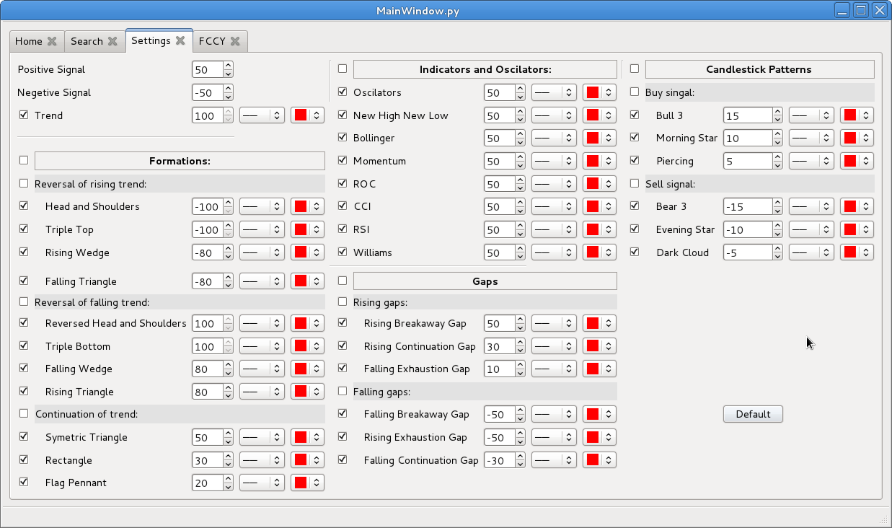
The Settings Tab with default values

7. Chart Tab
This tab contains the chart of a single financial instruments. It allows you to customize the type of chart and which elements to display on it. Here also you can launch our chart analysis feature as well as preview found chart formations and patterns.
On the bottom left corner there are date input fields that are used to set the time period to be displayed on the chart. To set a new time period, press OK after choosing the start and end dates. Note that if you choose a period when the instrument didn't exist, the chart will not be drawn.
Moving to the right, there is a box containing indicators and oscillators which can be drawn on a chart. Indicators such as moving averages and Bollinger bands are drawn on the main chart, whereas oscillators are drawn below the main chart. If you choose multiple indicators, a new window will open, where each indicator will be on separate chart. It is not possible to choose multiple oscillators.
Below indicators and oscillators controls there is also the “Show trend” checkbox, which is used to enable displaying trend channel lines on the chart. You can also customize the base line width. Actual channel lines thickness will depend both on this value and on the time horizon where the channel was found.
On the bottom-right part of the tab, further chart options can be found. You can choose data step: daily, weekly and monthly. It is recommended to choose weekly and monthly steps for longer periods, else the chart can become less readable. There is also a possibility to choose different chart types: linear, point, candlestick and OHLC bar chart. Another option is to choose between two scale types: linear and logarithmic. On the far right there are two checkboxes, first of them allows to hide volume bars to increase the area of main chart. It is useful especially with financial instruments where volume is not available, like futures contracts and bonds.
The second right-most checkbox is used to enable or disable drawing mode. In the drawing mode, it is possible to draw lines on the chart manually. To do this, just click consecutively on two different points on the chart. Each pair of clicks will be connected by a line. You can erase the last drawn line by clicking the right mouse button. To erase all lines, click the middle mouse button.
In the bottom-right corner there are two buttons, which are used to launch the technical analysis feature. First of them, the “Show chart pattern” button is used to find chart patterns (chosen in the Settings tab) and present them on the chart (of course, patterns will be displayed only if they are actually found). If you click it again, the patterns will be hidden. The second button is used to run the analysis algorithm and display its results on the Analysis Results tab.
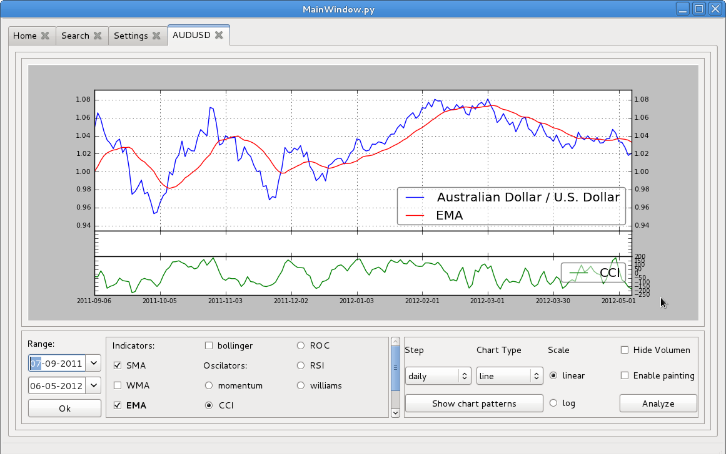
The Chart Tab with CCI oscillator and exponential moving average displayed
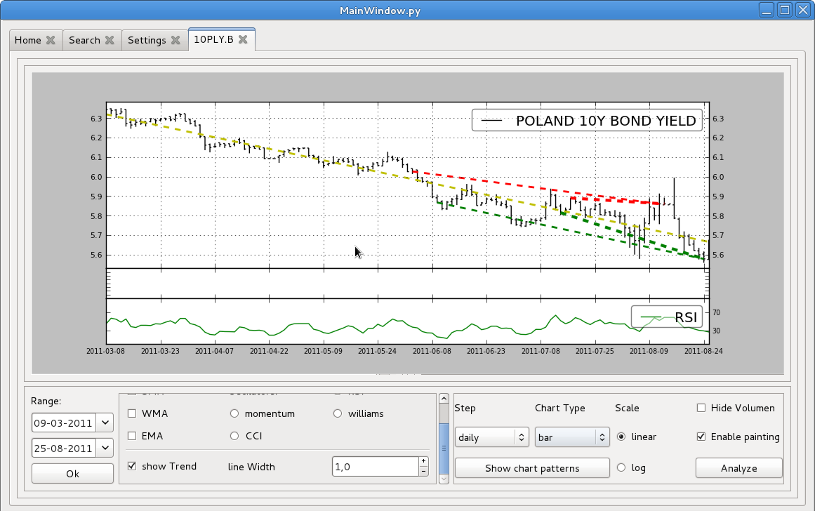
“Show trend” option on. This option presents channel lines found in short and long period as well as trend approximation using linear regression
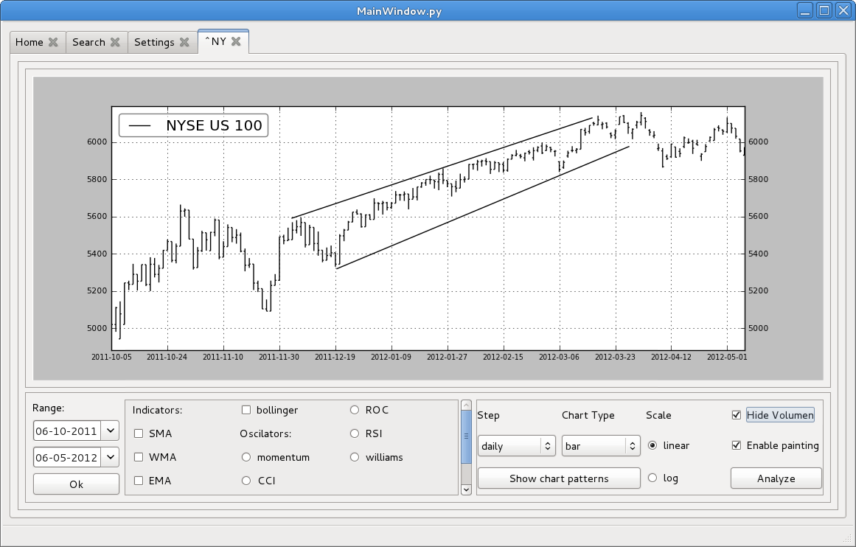
Bar chart with manually-drawn channel lines and hidden volume

8. Analysis Result Tab
This tab shows the summary of the analysis algorithm results. The algorithm tries to find all signals selected in the Settings tab and assigns values to them based on the signal strength values defined by the user. Base value of formations is scaled by a factor dependent on their size – formations that build up upon long time are valued more than those that are short. The final result is computed as sum of all values of found signals.
All of the found signals are presented on a list, where (+) means a positive signal, (-) represents a negative signal, and (0) means a neutral signal. Formations are also provided with their time span. Below the list there is overall score and short summary. Low scores (around 0) mean that negative signals are significantly stronger than positive. High scores (around 100) mean the opposite. Scores around 50 are considered neutral. It is important to remember that results may greatly vary depending on the values entered in the Settings tab.
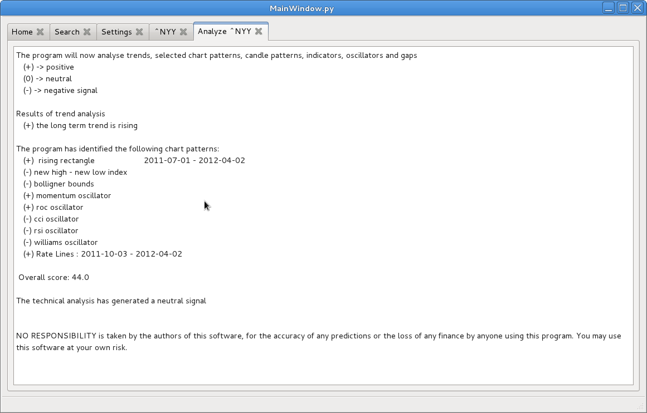
Technical analysis summary for the NYY index

9. Compare Chart Tab
This tab is activated when you click the Compare button in the Settings tab. It resembles the Chart tab, but it lacks some of its options.
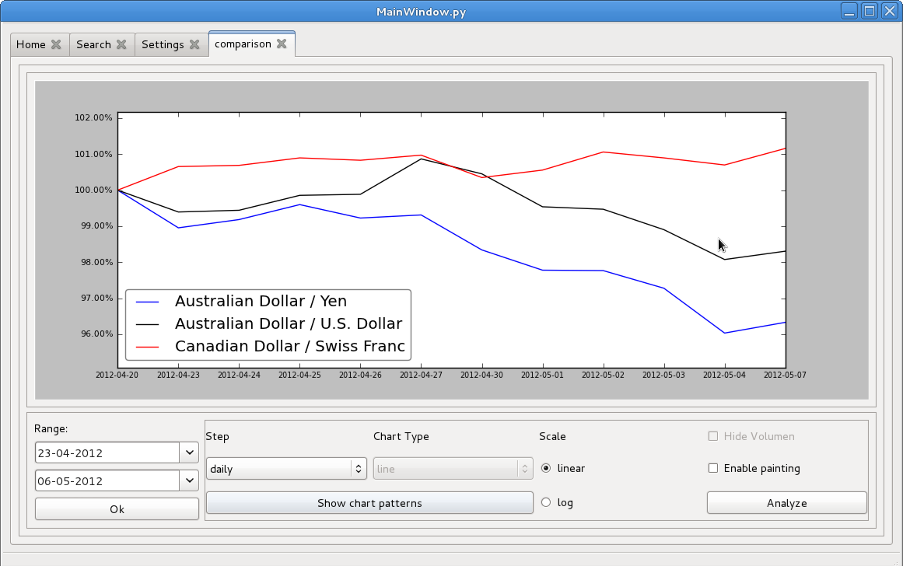
Comparison of different Forex currencies
The chart features which are missing here are: displaying indicators and oscillators, displaying volume, setting other chart type than line, showing patterns and analysis.
While the ordinary Chart tab depicts the value of a single financial instrument in its base unit (e. g. index points, USD, PLN, ...), Compare Chart tab shows comparison of percent change of values of different financial instruments.

